PF LAB

TASK 16/10/19

Q1,

#include <iostream>

using namespace std;

int main()

{

int i,j,rows;

cout<<"Number of Rows : ";

cin>>rows;

cout<<endl;

for(i=1;i<=rows;i++)

{

for(j=1;j<=i;j++)

{

cout<<"\*";

}

cout<<endl;

}

return 0;

}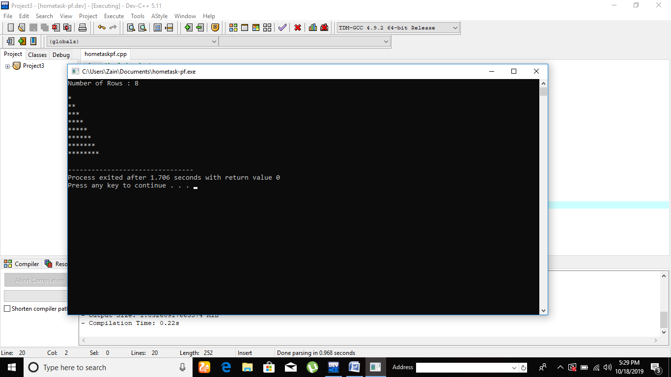

………………………………………………………………………………………………………………

Q2.

#include <iostream>

using namespace std;

int main()

{

int i,j,rows;

cout<<"Number of Rows : ";

cin>>rows;

cout<<endl;

for(i=rows;1<=i;i--)

{

for(j=1;j<=i;j++)

{

cout<<"\*";

}

cout<<endl;

}

return 0;

}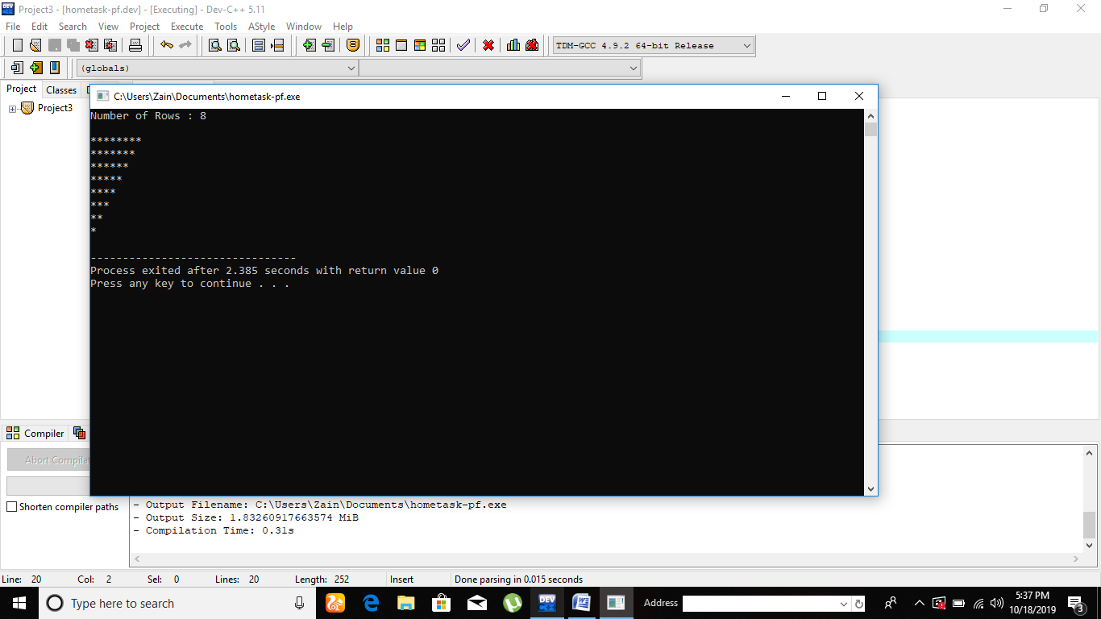

………………………………………………………………………………………………………………

Q3.

#include <iostream>

using namespace std;

int main()

{

int i,j,rows;

cout<<"Number of Rows : ";

cin>>rows;

cout<<endl;

for(i=1;rows>=i;i++)

{

for(j=rows;i<=j;j--)

{

cout<<" ";

}

for(j=1;j<=i;j++)

{

cout<<"\*";

}

cout<<endl;

}

return 0;

}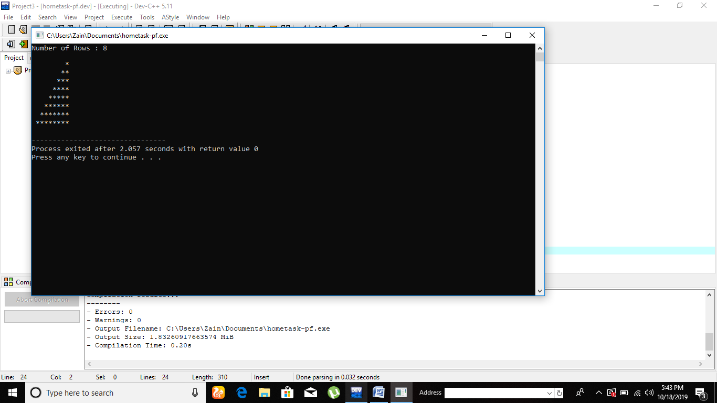

………………………………………………………………………………………………………………………………………………………………….

Q4.

#include <iostream>

using namespace std;

int main()

{

int i,j,rows;

cout<<"Number of Rows : ";

cin>>rows;

cout<<endl;

for(i=rows;1<=i;i--)

{

for(j=rows;i<=j;j--)

{

cout<<" ";

}

for(j=1;j<=i;j++)

{

cout<<"\*";

}

cout<<endl;

}

return 0;

}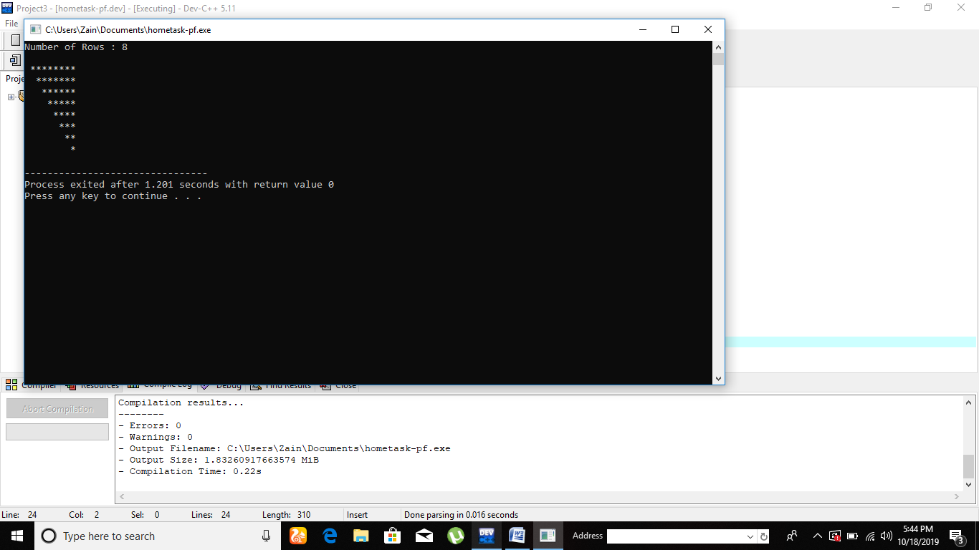

………………………………………………………………………………………………………………

Q5.

#include <iostream>

using namespace std;

int main()

{

int i,j,rows,k;

cout<<"Enter '1' for first type of Pyramid\n";

cout<<"Enter '2' for second type of Pyramid\n";

cout<<"Enter '3' for Third type of Pyramid\n";

cout<<"Enter '4' for fourth type of Pyramid\n";

cin>>k;

cout<<"Number of Rows : ";

cin>>rows;

cout<<endl;

switch(k)

{

case 1:

{

for(i=1;i<=rows;i++)

{

for(j=1;j<=i;j++)

{

cout<<"\*";

}

cout<<endl;

}

break;

}

case 2:

{

for(i=rows;1<=i;i--)

{

for(j=1;j<=i;j++)

{

cout<<"\*";

}

cout<<endl;

}

break;

}case 3:

{

for(i=1;rows>=i;i++)

{

for(j=rows;i<=j;j--)

{

cout<<" ";

}

for(j=1;j<=i;j++)

{

cout<<"\*";

}

cout<<endl;

}

}

break;

case 4:

{

for(i=rows;1<=i;i--)

{

for(j=rows;i<=j;j--)

{

cout<<" ";

}

for(j=1;j<=i;j++)

{

cout<<"\*";

}

cout<<endl;

}

}

break;

}

} 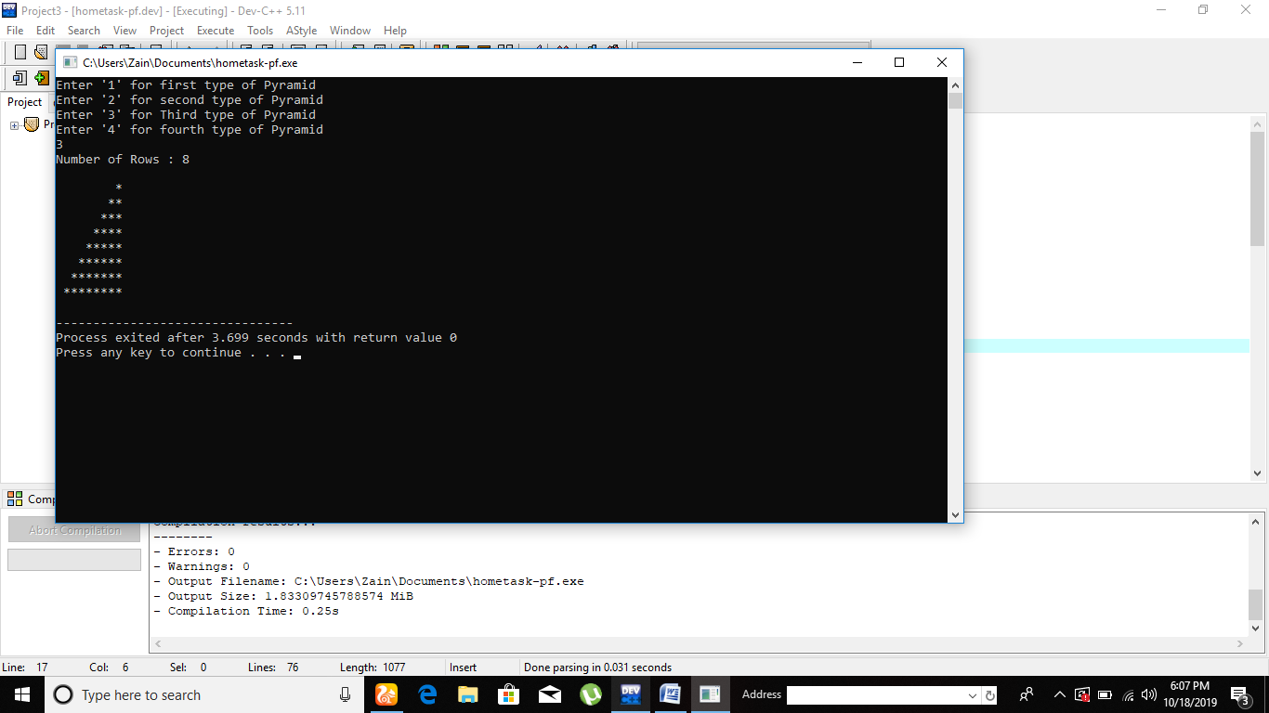

………………………………………………………………………………………………………………

Q6.

#include <iostream>

using namespace std;

int main()

{

int i,j,rows,k;

cout<<"Enter '1' for Square with Asterik\n";

cout<<"Enter '2' for Square with increasing numbers\n";

cout<<"Enter '3' for Square with decreasing numbers\n";

cin>>k;

cout<<"Number of Rows : ";

cin>>rows;

cout<<endl;

switch(k)

{

case 1:

{

for(i=1;i<=rows;i++)

{

for(j=rows;j>=1;j--)

{

cout<<"\* ";

}

cout<<endl;

}

break;

}

case 2:

{

for(i=1;i<=rows;i++)

{

for(j=rows;j>=1;j--)

{

cout<<i<<" ";

}

cout<<endl;

}

break;

}

case 3:

{

for(i=rows;1<=i;i--)

{

for(j=rows;j>=1;j--)

{

cout<<i<<" ";

}

cout<<endl;

}

break;

}

break;

}

}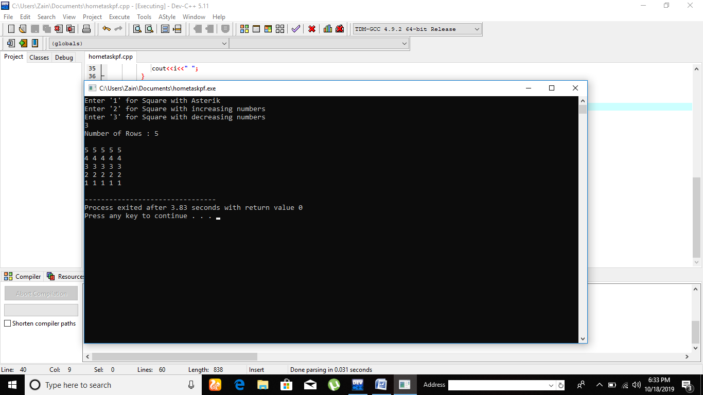

………………………………………………………………………………………………………………

Q7.

#include <iostream>

using namespace std;

int main()

{

int i,j,rows=0,k;

cout<<"Enter '1' for Triangle with Asterik\n";

cout<<"Enter '2' for Triangle with increasing numbers\n";

cout<<"Enter '3' for Triangle with decreasing numbers\n";

cin>>k;

cout<<endl;

switch(k)

{

case 1:

for(i=1;i<=5;i++)

{

for(j=5;j>=i;j--)

{

cout<<"\*";

}

cout<<endl;

}

break;

case 2:

for(i=1;i<=5;i++)

{

for(j=5;j>=i;j--)

{

cout<<i;

}

cout<<endl;

}

break;

case 3:

for(i=5;1<=i;i--)

{

for(j=i;j>=1;j--)

{

cout<<i;

}

cout<<endl;

}

break;

}

}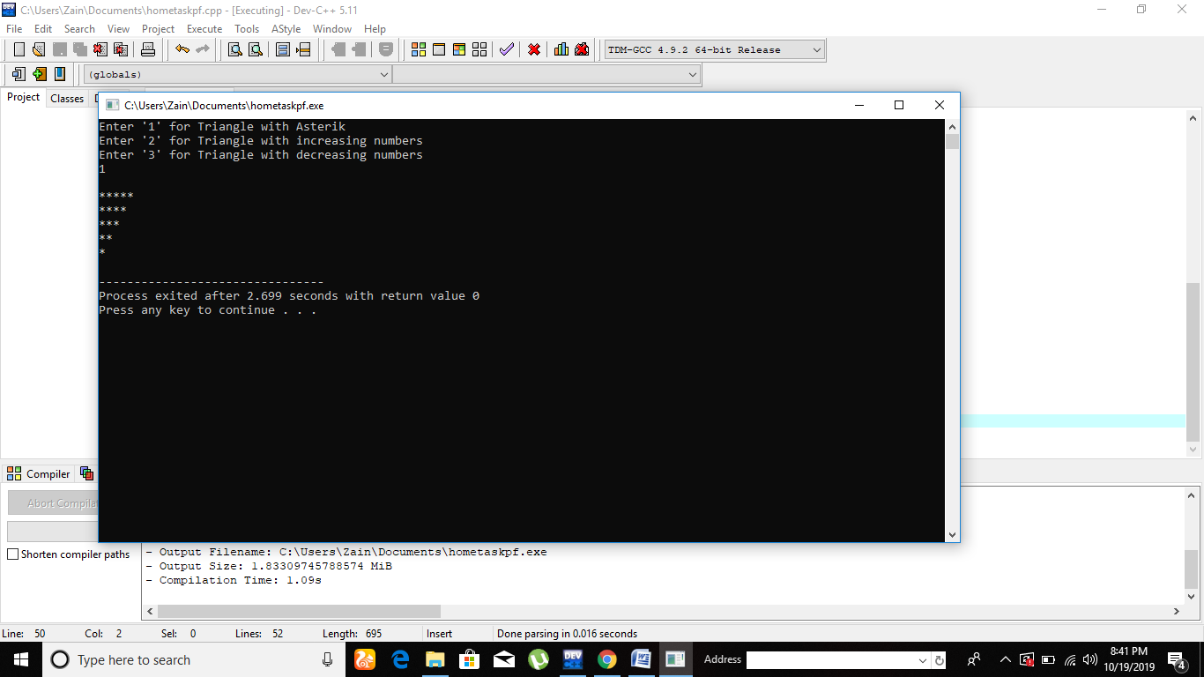………………………………………………………………………………………………………………

Q8

. #include <iostream>

using namespace std;

int main()

{

int i,j,rows=0,k;

cout<<"Enter '1' for first pattern\n";

cout<<"Enter '2' for Second pattern\n";

cout<<"Enter '3' for Third pattern\n";

cout<<"Enter '4' for Fourth pattern\n";

cin>>k;

cout<<endl;

switch(k)

{

case 1:

for(i=1;i<=5;i++)

{

for(j=5;j>=1;j--)

{

cout<<i;

}

cout<<endl;

}

break;

case 2:

for(i=1;i<=5;i++)

{

for(j=1;j<=5;j++)

{

cout<<j;

}

cout<<endl;

}

break;

case 3:

for(i=5;1<=i;i--)

{

for(j=5;j>=1;j--)

{

cout<<i;

}

cout<<endl;

}

break;

case 4:

for(i=1;i<=5;i++)

{

for(j=5;j>=1;j--)

{

cout<<j;

}

cout<<endl;

}

break;

}

}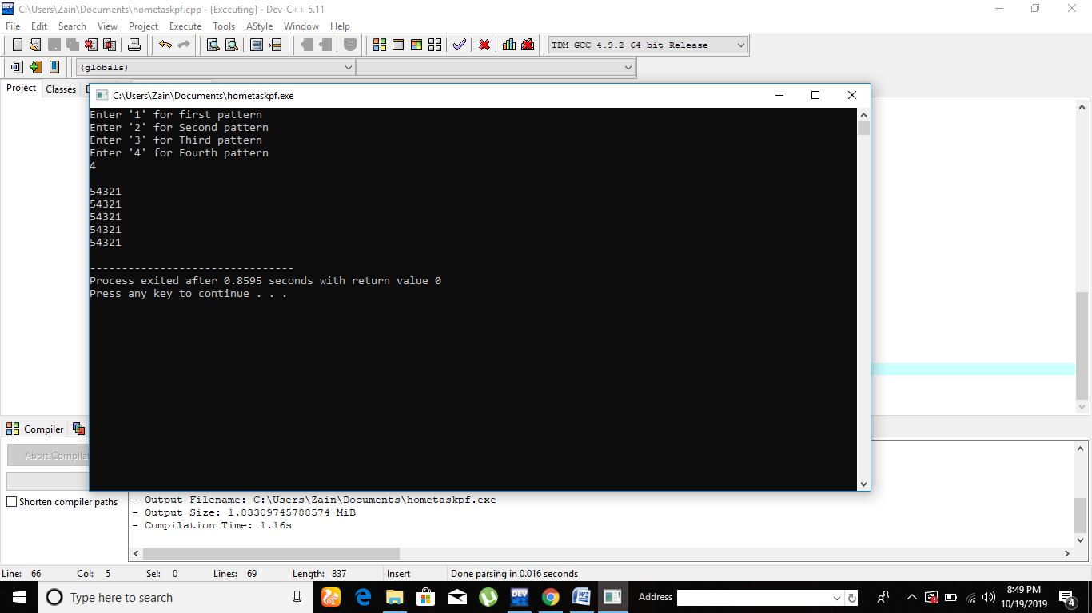

………………………………………………………………………………………………………………

Q9.

#include<iostream>

using namespace std;

int main()

{

int i,j;

for(i=1;i<=4;i++)

{

for(j=3;i<=j;j--)

{

cout<<" ";

}

for(j=1;j<=i;j++)

{

cout<<"\*";

}

for(j=2;j<=i;j++)

{

cout<<"\*";

}

cout<<endl;

}

}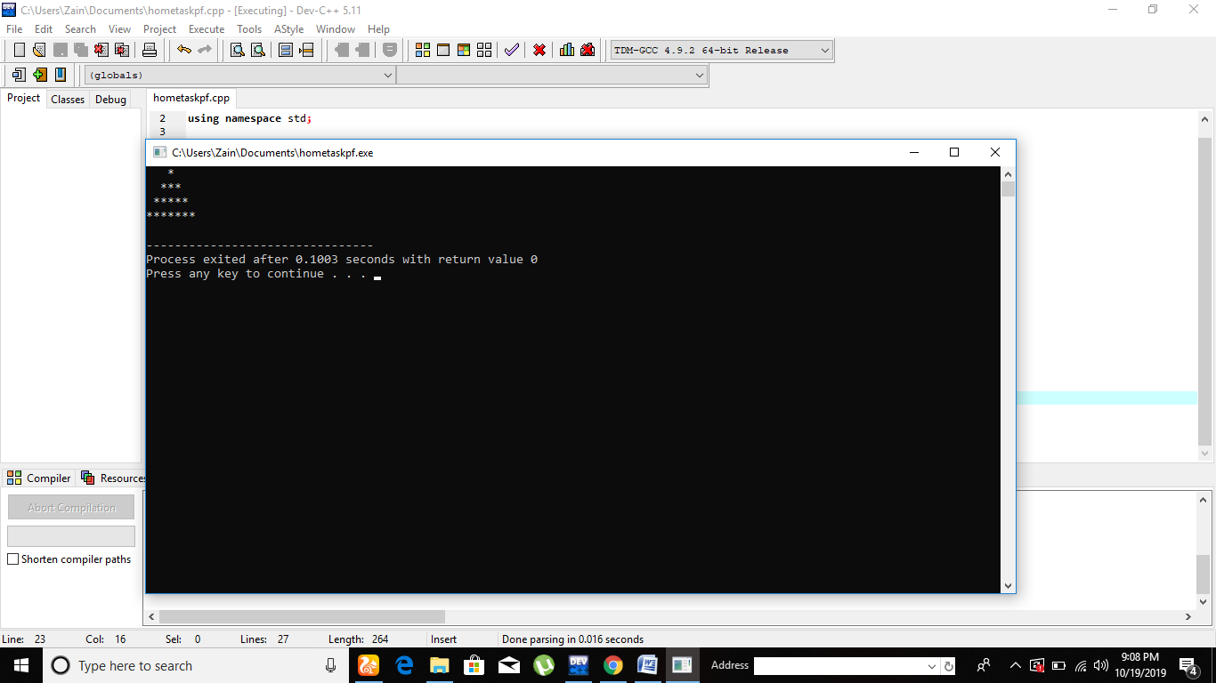

Inverted.

#include<iostream>

using namespace std;

int main()

{

int i,j;

for(i=4;1<=i

;i--)

{

for(j=3;i<=j;j--)

{

cout<<" ";

}

for(j=1;j<=i;j++)

{

cout<<"\*";

}

for(j=2;j<=i;j++)

{

cout<<"\*";

}

cout<<endl;

}

}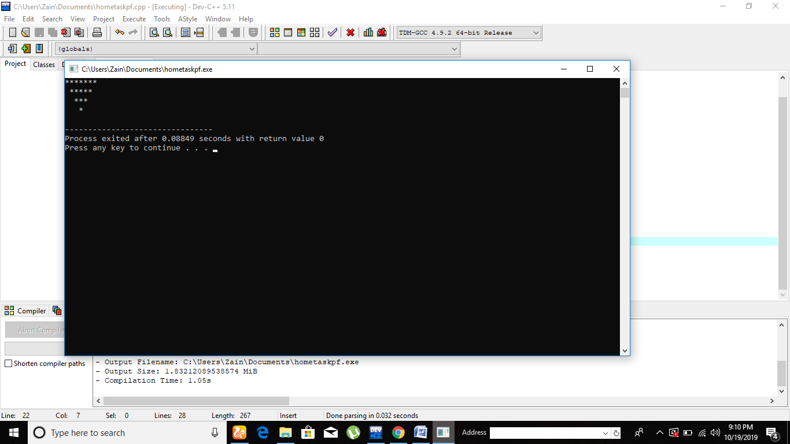

………………………………………………………………………………………………………………

Q10.

#include<iostream>

using namespace std;

int main()

{

int i,j;

for(i=1;i<=4;i++)

{

for(j=3;i<=j;j--)

{

cout<<" ";

}

for(j=1;j<=i;j++)

{

cout<<"\*";

}

for(j=2;j<=i;j++)

{

cout<<"\*";

}

cout<<endl;

}

for(i=3;1<=i;i--)

{

for(j=3;i<=j;j--)

{

cout<<" ";

}

for(j=1;j<=i;j++)

{

cout<<"\*";

}

for(j=2;j<=i;j++)

{

cout<<"\*";

}

cout<<endl;

}

}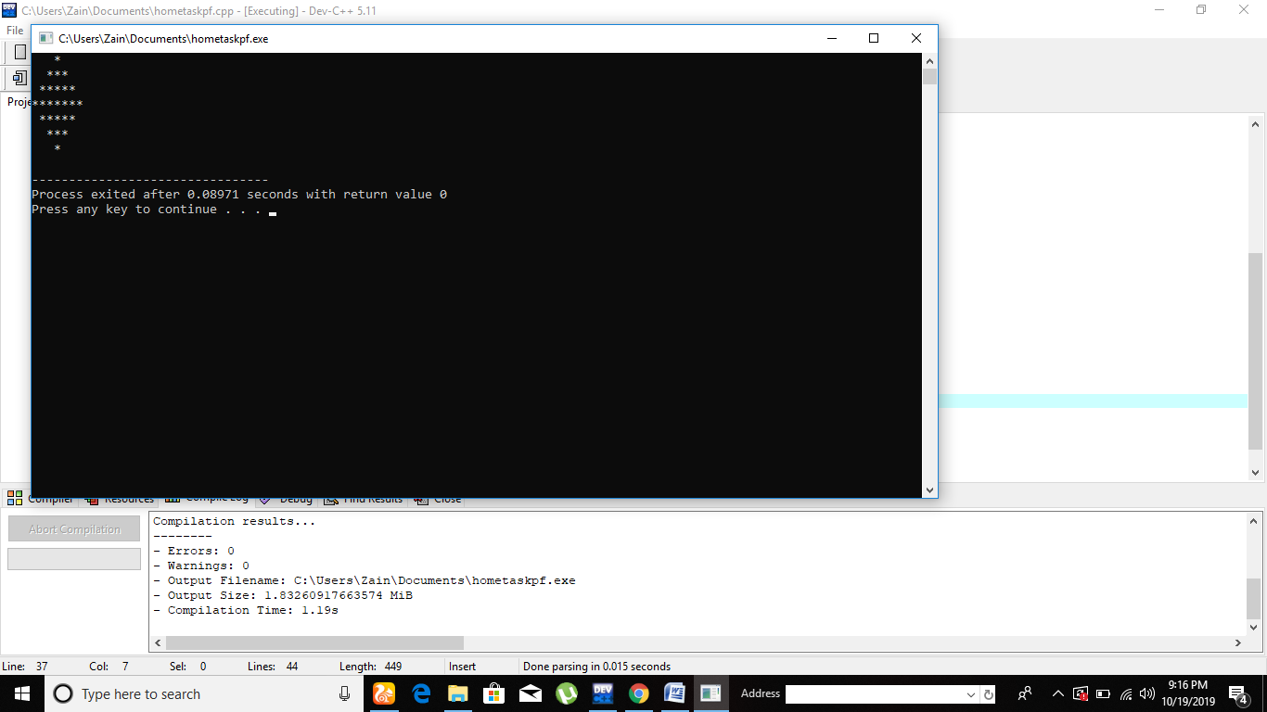

………………………………………………………………………………………………………………

Q11.

#include<iostream>

using namespace std;

int main()

{

int i,j;

for(i=5;1<=i;i--)

{

for(j=1;j<=i;j++)

{

cout<<"\*";

}

for(j=5;j>i;j--)

{

cout<<" ";

}

for(j=1;j<=i;j++)

{

cout<<"\*";

}

cout<<endl;

}

for(i=1;i<=5;i++)

{

for(j=1;j<=i;j++)

{

cout<<"\*";

}

for(j=5;j>i;j--)

{

cout<<" ";

}

for(j=1;j<=i;j++)

{

cout<<"\*";

}

cout<<endl;

}

}

